Investment Summary Hadden Estate
Walters Hospitality | Pre-LOI Pro Forma | $ in thousands
Target close  Aug 13, 2026 (mid-month) | Location  [city, state] | Deal terms  [price / structure] | Comparable WH venue  ATL

1. The venue
Market  [zone 1 / 2 / 3; drive time to hubs] | Performing or growth?  Flat event count; revenue per event rising  Growth case rests on new bookings and vendor services | Vendor services today  Room rental and lodging only  No in-house food or beverage | Employee structure  5 staff: planner, coordinator, sales, 2 maintenance  [owner involvement]

2. Events and headline P&L
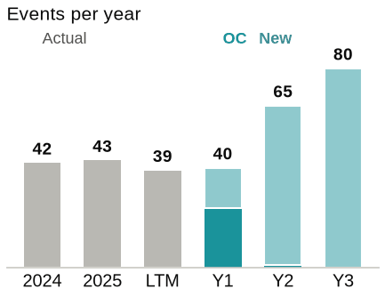 | 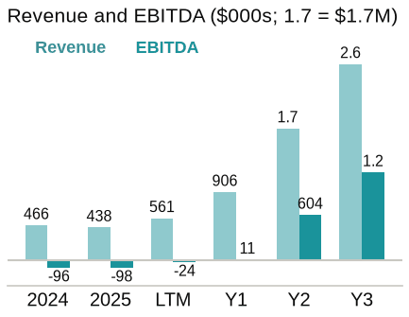
 | 2024 | 2025 | LTM Jul-26 | Year 1 | Year 2 | Year 3
Events | 42 | 43 | 39 | 40 | 65 | 80
OC / new | actual | actual | actual | 24 / 16 | 1 / 64 | 0 / 80
Revenue per event | 9.6k | 9.4k | 14.0k | 22.4k | 26.8k | 32.5k
Revenue | 467k | 438k | 561k | 906k | 1.75M | 2.60M
Gross margin | 380k | 395k | 512k | 891k | 1.67M | 2.43M
Payroll | (195k) | (230k) | (275k) | (317k) | (398k) | (508k)
Operating expenses | (281k) | (263k) | (260k) | (277k) | (381k) | (457k)
EBITDAR | (96k) | (98k) | (24k) | 296k | 889k | 1.46M
Rent (post-close) | – | – | – | (285k) | (285k) | (296k)
EBITDA | (96k) | (98k) | (24k) | 11k | 604k | 1.17M
Year 1 begins at close. OC = original contract events booked by the sellers before close.

Investment Summary Hadden Estate | Assumptions

3. Vendor services plan
Attachment = share of new-contract events that add the service; $ / event is the Walters average used
Service | Today | Attach Y1 | Attach Y2 | Attach Y3 | $ / event | WH ATL attach
Bar (beverage) | None in-house | 50% | 75% | 100% | 0.75k | –
Catering (food) | None in-house | 0% | 50% | 100% | 5.05k | –
Lodging | ~50% of events | 50% | 50% | 50% | 3.00k | –
Floral | None | 7% | 24% | 48% | 3.26k | 48%
Bakery | None | 5% | 16% | 32% | 1.13k | 32%
DJ | None | 12% | 38% | 61% | 1.69k | 77%
Stationery | None | 12% | 39% | 78% | 0.79k | 78%
Photography | None | 5% | 17% | 34% | 1.11k | 34%
Bar is an on/off switch once licensed. Catering starts Year 2. Floral, bakery, DJ, stationery and photography ramp to the ATL average by Year 3.

4. Expense assumptions
Payroll  - Current 5 staff carried at 5% YoY  - Add ancillary and F&B payroll as services go live  - [owner pay vs. replacement cost] | COGS  - Little COGS today  - Food, alcohol and ancillary COGS at Walters margins as services attach | Operating expenses  - Marketing steps up to ~67k from ~22k LTM  - Insurance ~30k, property tax ~35k  - Rent 285k post-close

5. Marketing funnel
No venue lead or tour history; conversion rates are Walters averages
 | Year 1 | Year 2 | Year 3
Leads | 1500 | 1750 | 2000
L→T conversion | 20% | 20% | 20%
Tours | 300 | 350 | 400
T→C conversion | 27% | 26% | 25%
Contracts | 80 | 90 | 100

6. Risks and open items
- Funnel rests entirely on Walters conversion rates; no venue history to check against
- Year 2 and 3 revenue depends on catering and bar going live on schedule
- Rent of 285k post-close is the gap between EBITDAR and EBITDA
- [owner transition and replacement plan]
- [market zone and hub distance; which services can we actually serve]
- [diligence items outstanding]

